Data Science Foundations

Introduction

Data science it is apparent that this profession is transforming the manner in which businesses and institutions manage information. It is possible that by combining the best computers available today with the most innovative use of statistics to make predictive discoveries and sound knowledge of the fields it deals with, organizations can extract valuable information out of the terabyte size data that they churn out on a daily basis. In the paper, I would like to pay particular attention to the fundamental concepts, practical applications, and ethical considerations of working with such large amounts of data.[1]

In order to begin, data science is based on higher tools, such as machine learning, artificial intelligence (AI), and big data analytics, in order to reveal latent patterns, forecast what would happen next, and automate essential decisions. Regardless of whether the end goal is customer satisfaction through personal recommendations, real-time fraud detection or medical research acceleration through predictive modeling, data science is rapidly transforming the way companies and organizations operate.

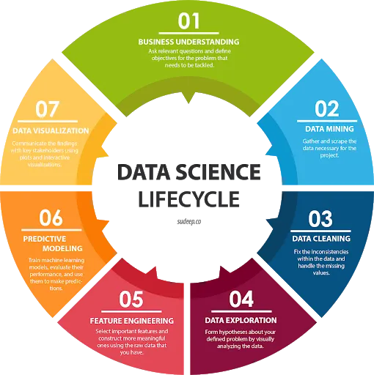

Naturally, the fast development of data science comes with severe concerns and ethical problems as well. The issue of data privacy and bias in algorithms as well as the general responsible AI should all be taken seriously to ensure that solutions based on data remain equitable, predictable, and socially positive. To ensure the risks associated with heavy use of data are kept in check and the benefits of the same are only tapped, the professionals must combine the excellent technical abilities with the sound sense of ethical responsibility as the area continues to advance.

Data Science Landscape

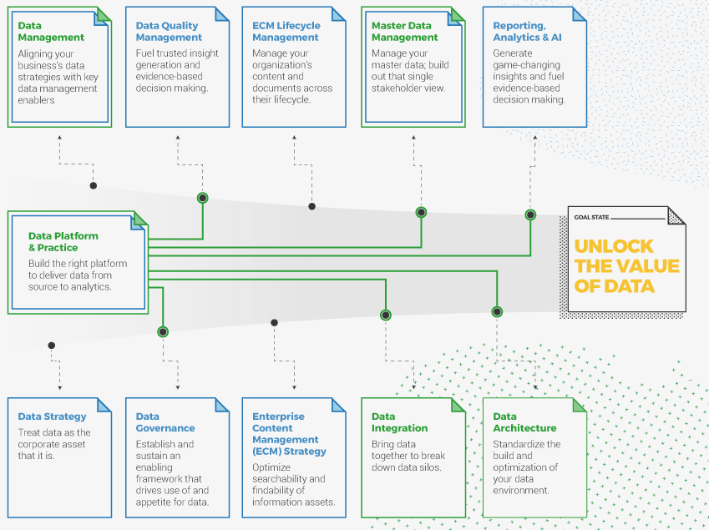Taking a closer look at what data science entails it becomes quickly apparent that it revolves around three primary disciplines, statistics, computer science and whatever expertise is applicable to a given issue. Statistical measures allow us to identify trends and even forecast.

Computer science gives us such algorithms and systems that can quickly and successfully chew through massive datasets. Best domain knowledge serves as that glue that holds all that technical strength to the actual problem at hand. [2]

Consider Netflix to be an ideal case study. Their recommendation algorithm is a combination of statistical modeling and machine-learning tricks in order to log what users are watching and computer scientists ensure that the machinery under the hood can span a path of millions of interactions by users in each and every day. Through these insights, the content experts know what programs and films to introduce next to make them stay on their screens.

Components of Data Science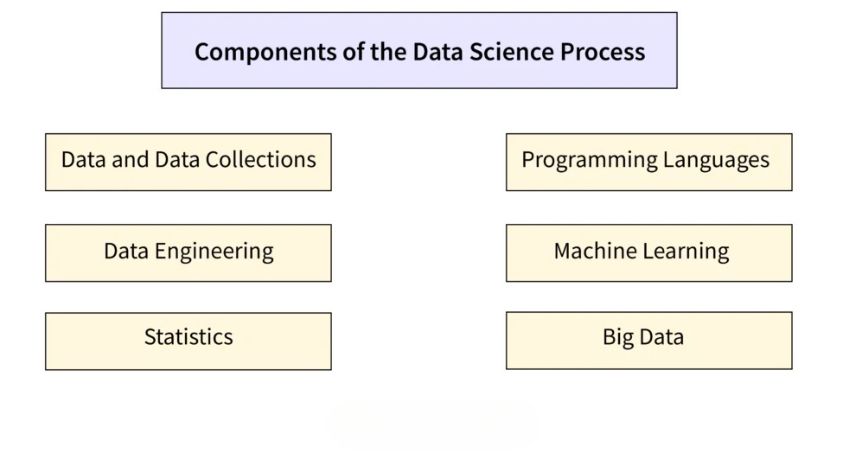

When we discuss data science, what we have is literally an interdisciplinary mash-up: used together, statistics, computer science, and domain-specific expertise find their way to producing order out of chaos, transforming noisy data into something useful.

In a bid to arrive at that stage, we adopt an expected lifecycle that consists of a couple of core stages.

1. Data collection. Then there is harvesting of the data itself. We scrape the web, finger databases, ping APIs, tap sensors or whatever gets us the figures that we require. The raw material is normally noisy, disorganized, and incomplete so it results in.

2. Data preprocessing. An ugly preparation stage. And here we clean up the mess: we drop the duplicates, impute the missing entries, harmonise the incompatibilities, and squash the whole mess into a presentable, orderly set which we can actually utilise.

3. Exploratory data analysis ( EDA ). Now at a loss we grow curious. Our statistical summaries, scatter plots and histograms and all types of various representations come grist to the mill in trying to find patterns, correlations and anything strange. The role of EDA is two-fold: it directs the following stage and makes us keep feet on the ground.

4. Feature engineering. Here we will create new variables and/or modify the old ones in order to improve the model. Good feature engineering is a common difference between a good and a great model.

5. Model building. Our features are determined, and this is when we head to the algorithm toolkit. Depending on the task, we can use linear regression, decision trees, support vector machines (or perhaps even neural networks). All algorithms are iteratively trained to a point where they may predict or classify with reasonable accuracy.

6. Model validation. We do not simply accept what it says. Validation (more often cross-validation) serves to make sure we verify the confidence of our model. We run the numbers, tweak hyperparameters and push performance through accuracy, precision, recall and F 1 -score as our best friends.

7. Model deployment. When we manage to hook the model into a website, an IoT hub, or a mobile app, we must hook it to the real systems where the model can work on its own.

8. Maintenance and monitoring of the models. The trends in data also shift even when nothing appears to be amiss. Periodic reviews with the performance indicators ensure that we do not go rusty.

9. Visualization and communications of data. Last but not least, the technical output must be sensible to the laypeople. Charts, dashboards and reports convert the jungle of numbers into something people can follow through with. The combination of these steps compose the backbone of the data science workflow and results in innovation, efficiency, and more intelligent decisions in nearly every industry.[1]

Data Scientist's Role

Data scientists are a different breed in the IT. Whereas business analysts rummage through past trends to perfect how an organization operates on the daily basis, data scientists fantasize the creation of predictive models that speculate what will be the reality in the future. Imagine going one building an algorithm that identifies which customers appear to be abandoning the brand, and another working out the bottom line impact of a big reduction in churn.

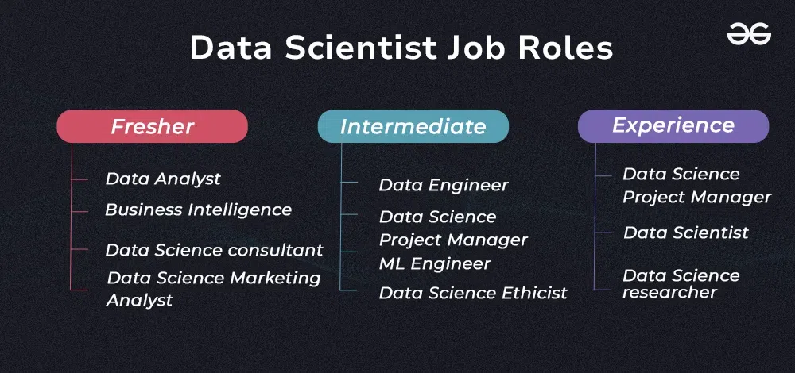

This discipline itself spans several overlapping and sometimes even separate specialties and each of them maintains the data science lifecycle going. DS-PM puts forward the key competitors: Data Scientist: marriage between stats, coding and industry knowledge, the unicorn. They also reduce business issues, discover the data, develop predictive models and explain what the figures signify. Fortune played out cerebrating machine learning alongside grand analysis to intercept blind patterns and predict results. Data Engineer- the architect that designs, constructs and maintains data pipeline that is reliable, scalable and efficient. They are the back-end engineering team, and they may be using Hadoop, Spark or SQL databases to ensure that everyone else has clean and well-structured data.

Data Analyst- working within the reporting layer. They jump into numbers and identify trends to provide actionable insights that no business can do without, and provide analysis with a business context by and large through Excel, SQL/Server, Tableau, or Power BI dashboards and reports, which serve as an intermediary between raw numbers and business analysis.

Machine Learning Engineer- the task of the representative is to get machine learning models into production. Once the data scientist tests, the machine learning engineer ensures that the models can scale, remain dependable and fit into the real-time use case.

Business Analyst and Domain Expert- are important players on the connection between the data and the real world objectives and strategy strategies. They ensure that all analyses are in line with what the business requires.

Data Architect and Database Administrator (DBA) the ones who ensure that data is stored, secured and the way it is structured. They deal with data availability and maintain the system compliant. In combination, these roles create an ecosystem of collaboration, turning raw data into strategic business value, and where each is team member is playing an essential role in the process.

Big Data

The big data has completely transformed organizational work and competition. The retail giants are now sieving through billions of transactions to manage inventory and forecast purchases. Banking establishments use well-developed mathematical formulas to detect frauds on a real- time basis. Health care providers will be alerting vulnerable patients even before severe symptoms appear. The term big data refers to highly large and complicated data sets that cannot be effectively handled, stored and analysed by conventional tools. It is many a time diverted to as the 3 Vs i.e., Volume, Velocity, and Variety. By volume is meant the sheer quantity of information generated every second with the use of social media, sensors, transactions, and mobile devices. Velocity highlights the speed at which this data is generated, captured and pre-processed either in real time or close to real time. Variety refers to the various types of data- structured (e.g. spreadsheets and databases), semi structured (e.g. XML or JSON documents) and unstructured (e.g. video, images and free text). Big data is transforming innovation, efficiency, and decision-making in an immeasurable amount of industries. It allows organizations to detect buried trends, relations or form insights, which are no longer elusive. Big data can be used in companies to enhance customer experiences, generate customers, streamline customer experience operations and create superior products and services. Massive data are handled through the use of sophisticated tools and technologies, including distributed computing systems, cloud storage, and big data analytics systems, such as Hadoop and Apache Spark, among others, by the organizations. These are frameworks that will allow storage and processing of large amounts of data on multiple machines and are observant toward scalability and performance. [2]

Modern applications of machine learning and artificial intelligence and real-time analytics are powered by big data and have transformed crude data into valuable information. The use of these tools enables one to communicate complex findings to the stakeholders much easier. Sectors such as the healthcare, finance, manufacturing, transportation sectors also rely on big data to address complicated issues and obtain a competitive advantage. With the increase in the amount of data and improvement in its speed, learning to use big data is the only way to achieve success in the digital world. But with this data-driven revolution there is a lot that is burdened. Increased privacy concerns have resulted in such severe laws such as GDPR, and therefore business organizations must resort to high level data protection. It is in the interest of organizations to strike a balance between the enormous benefits of data analytics and the customer-related requirement of protecting their information and the need to apply the data ethically.[3]

Structured

Semi -structured

Unstructured

Digital Transformation

In simple terms, big data can be used to define the future of digital transformation across all industries as it allows businesses to make more calculated, faster and more knowledgeable decisions daily. With the help of large data sets, companies will be able to identify real-time changes, create customer experiences, and enhance the efficiency of all processes. A good example is dynamic pricing algorithms that adjust prices in real-time responding to changes in demand, competitor action, inventory manipulation and overall market fluctuations. Using such algorithms, companies remain competitive and milk more money. Another immense means, through which big data disrupts the world, is automated customer service. Chatbots and talking robots attend to simple questions, whereas the site collects and analyzes the responses in order to provide firms with a better understanding of what users seek. With such intelligence, organizations are able to enhance service providing thereby increasing satisfaction of the customers. Since the systems relieve human agents of the regular questions, teams can focus on more valuable work. Another important area is the predictive maintenance which has been completely transformed by big data. Using sensor values and usage patterns, the companies will be able to predict when equipment will break down before they explode. That cuts down in idle time, avoids costly repairs and prolonged service. It is a big-time boost on manufacturing, logistics, and aviation.

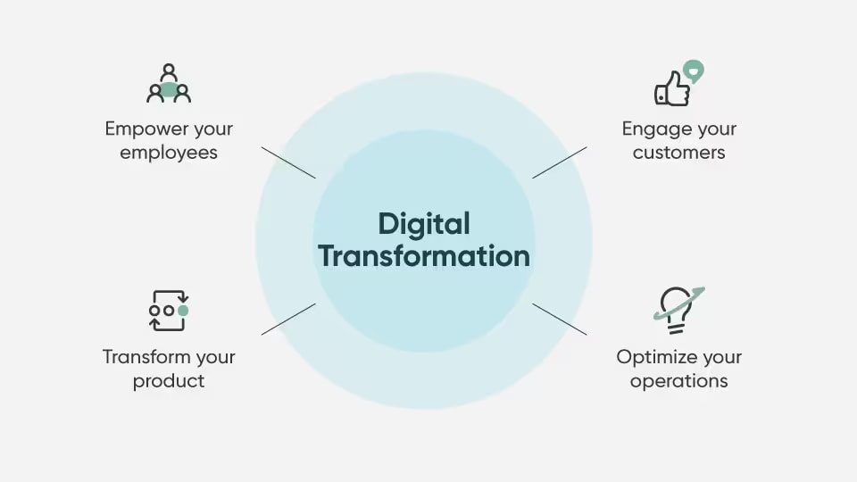

Moreover, the advanced analytics have revolutionized employee management too. Predictive models are used in HR departments to evaluate the risk of employee turnover, the areas of competencies, and the directions in recruiting and training. These revelations assist in smarter hiring, maintaining and planning. Data analytics enhancement on collaboration tools can also boost productivity, particularly in the hybrid and online working conditions. Such instruments will monitor the project progress, evaluate communication flows, and find bottlenecks, allowing the team to work more efficiently in diverse time zones and geographies. In sum, big data allows organizations to shift the processes to proactive rather than reactive approaches, and it also equips the agility and intelligence of success in the digital economy. It does not only imply a technological upgrade, but a decisive innovation and transformation.

Essential Tool

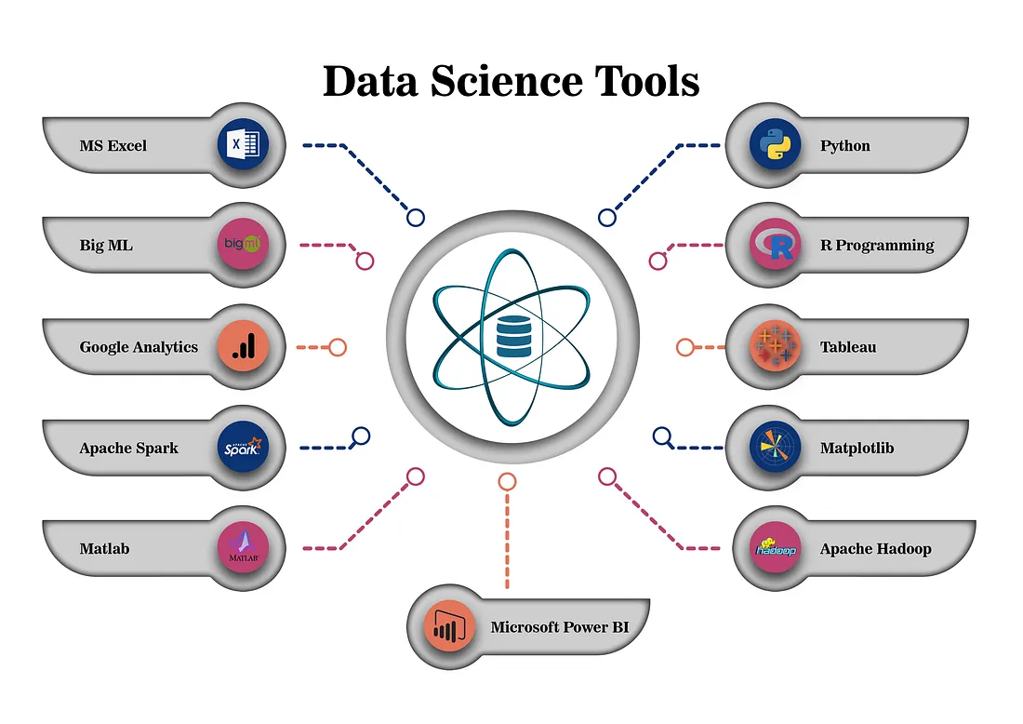

Data science ecosystem has a broad set of tools that aim to deal with all the aspects of the data lifecycle. Essentially, the programming languages like Python and R cannot be avoided in cleaning, manipulating, analyzing or visualizing data. Full libraries and frameworks such as Pandas, Scikit-learn and ggplot2 back up these languages, giving data scientists the power to create machine learning models and conduct highly complex statistical analyses in a streamlined way.

In working with large quantities of data, big data platforms like Hadoop and Apache Spark provide, a distributed computing power that allows an organization to handle data sizes that are way beyond the capacity of a conventional database. Such systems are needed in real time analytics, as well as large scale data applications. [3]

Regarding the presentation of data results, such availability of visualization tools as Tableau, Power BI, and Plotly allows providing data results in new interesting ways. The dashboards assist with the technical teams and business stakeholders communication gap and improve data-informed decision-making. Besides, cloud options with AWS, Google Cloud Platform, and Microsoft Azure offer scalable and on-demand facilities. The services help with data storage and model training through to deployment and monitoring, and make sure data science projects are flexibly, scalably and cost-efficient. Combined, the tools comprise the core of contemporary data science operations.

Data Processing

Apache Hadoop is one of the supporting technologies surrounding big data processing. It is set up to deal with large amounts of information and it has a distributed file system that breaks up large datasets into smaller manageable blocks and places them on a cluster of servers. The architecture enables optimal, fault resistant storage and retrieval of information.

Meanwhile, the processing framework of Hadoop, especially MapReduce, allows the computation of processes to be done congruently on the various data sections. This parallel computing significantly speeds-up the data analysis and it even becomes a possibility to draw conclusions out of big-data. The use of Hadoop is especially common within the various industries. It is used by social media companies in the process of analyzing the interactions among their users as well as by healthcare institutions in the provision of patient data and facilitation of research. The fact that it can be scaled horizontally (within an organization) with an additional number of servers implies that it is feasible in organizations that exhibit exponentially expanding data.

Generally, Hadoop is a very efficient and reliable tool in handling and analysing big data. [4]

Artificial Intelligence

Artificial Intelligence ( AI ) is changing the industries as machines are getting the capacity to do the duties, which were considered to need human intelligence earlier. Its usages are yielding phenomenal outcomes in areas and propelling effectiveness, precision, and imagination.

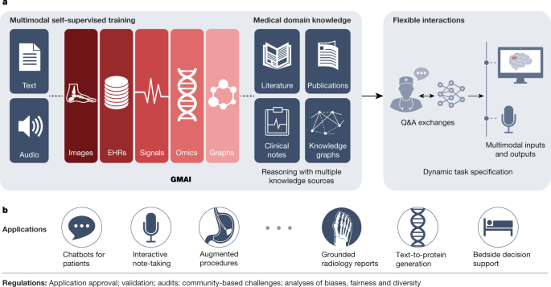

The diagnostic systems that employ AI can process medical images, identify the patterns, and predict possible health problems, showing a level of precision that potentially exceeds, or at least is equal to, medical experts. The technology facilitates diagnosis faster and more accurate and enhances the outcome of patients through their tailored treatment plans. The financial sector is one of the main areas where the institutions are making use of AI in monitoring fraudulent activities through transaction patterns in real-time. [4]

Machine learning models can also be employed when it comes to checking creditworthiness, dealing with risks, and automating customer service with the help of an intelligent chatbot. In the same way, in retail business, AI can be used to improve the customer experience to review user behavior and make goods suggestions, align stocks, and tailor marketing approaches via predictive analysis. Infringing on its advantages, AI poses great challenges; these are to be dealt with carefully. Bias in training data is one of the essential issues that may lead to unfair, discriminatory, or misleading results of the systems. In this regard, automation hiring tools can advantage one group unfairly without having to monitor and test them. This underlines the need of transparency, ethical norms and inclusive data management. In addition, the fact that the formerly new capabilities of AI become ordinary expectations is known as the "AI effect".

Due to the current fast development of AI technologies, organizations are under constant pressure to update their innovations in order to remain on top. Operating in the AI-driven world would not only presuppose the implementation of AI tools but the development of them in a responsible and strategic way. The future of AI is the reconciliation of its enormous potential with a moral and sustainable growth .[5]

Ethical Data Practices

Ethical considerations are being of greater significance as data is becoming prominent in the spheres of business operations. Data collection and use is more transparent, and it makes customers and regulators trust the company. Safeguards of accountability make automated decision systems to have suitable supervision. With the help of fairness audits, biases in algorithms are discovered and eliminated.

The Facebook-Cambridge Analytica case showed what would happen when data ethics was not adhered to. Reacting to the same, various organizations are now deploying data governance teams and reference models such as the UK Data Ethics Guidelines in order to make sure that they are using these powerful technologies responsibly.[6]

Conclusion

Data science has become a mainstream business strategy leading to innovation in businesses. The integration of high quality analysis tools, huge computer capacities and expertise in the field helps organizations to generate more value than ever using its data resources. Nevertheless, such power is accompanied by a great responsibility to define the moral application of data, data security, and fairness. Firms which manage to find a successful balance between these technical possibilities and ethical aspects will be the best prepared to succeed in our newly data-driven world.

References

1.Laney, D. (2001). *3D Data Management: Controlling Data Volume, Velocity, and Variety*. Gartner.

2.Amazon Web Services (AWS). (2023). *Big Data Analytics with Hadoop*. Retrieved from <https://aws.amazon.com/big-data/datalakes-and-analytics/what-is-big-data-analytics/>

3.NTT Ltd. (n.d.). *Customer Experience and Digital Services*. Retrieved from <https://services.global.ntt>

4.Talend. (n.d.). *Data Integration and Integrity Platform*. Retrieved from <https://www.talend.com>

5.https://medium.com/tag/artificial-intelligence

6.Harvard Business Review. (2020). *The Ethics of AI*. Retrieved from <https://hbr.org>

Image References

1. HEAVY.AI. *Big Data Visualization*. Retrieved from <https://www.heavy.ai>
2. Info-Tech Research Group. *Data Strategy Framework*. Retrieved from <https://cdn1-public.infotech.com>
3. GeeksforGeeks. *Machine Learning Algorithms*. Retrieved from <https://www.geeksforgeeks.com>
4. Medium. *Data Science Articles and Case Studies*. Retrieved from <https://medium.com>